Complex Networks
A3. Epidemic spreading on complex networks
MESIIA 2024-2025
Suiwen Dong, Mark Safronov

Simulation setup
The solution has been performed in Python, using built-in components from the NetworkX library.
The code uses the networkx.erdos_renyi_graph function to generate the ER network, and similarly, networkx.barabasi_albert_graph function to generate the BA network. Networks are being generated on-the-fly, we did not consider storing them in the files. Each simulation run uses its own randomly generated network instance.
The amount of nodes in each network is 1000. Upon starting the Monte Carlo simulation, 20% of the nodes are marked as infected.
We considered ER and BA models with k = 4 and k = 6. Two cases has been simulated, with and with . For all four combinations of k and μ we additionally generated the MMCA theoretical prediction.
In addition to the plots showcasing all the combinations at the same time, the raw result tables from the same run were stored separately in CSV files which go alongside this report.

Simulation at μ = 0.2
The results of running the simulation at are being presented on Figure 1.
We can make several observations from it.
- For BA models the epidemic processes start earlier (with lesser infection probability). It can be said that BA models has lower epidemic threshold. It can be attributed to the BA models being characterized by the large hubs with high connectivity.
- With the same average degree value and with large infection probability, both BA and ER models converge to the same infected fraction ρ. This can be interpreted as that choice of the model doesn’t matter if the infection probability is high.
- MMCA consistently predicts larger ρ values with earlier thresholds, in all four combinations of the network model and an average degree. This can be explained by the assumption of independence among nodes in MMCA.

Simulation at μ = 0.4
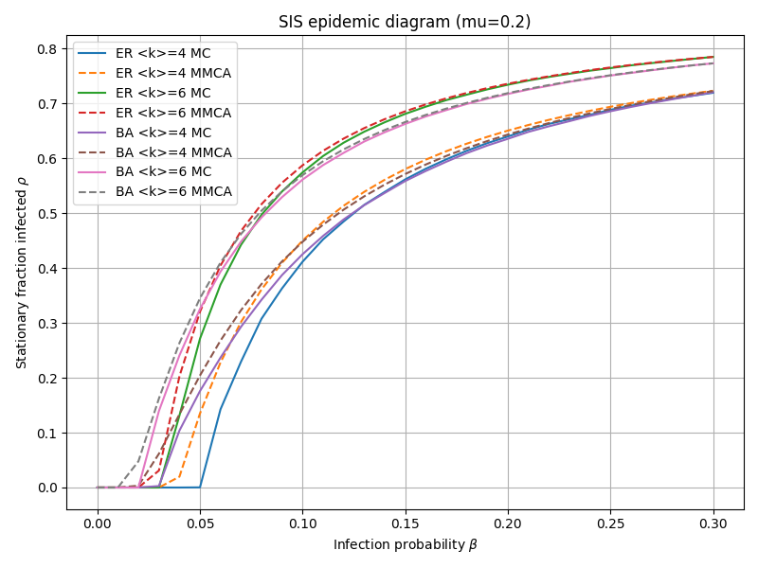Figure 1: Infected fraction versus infection probability at stationary state, given μ=0.2
The results of running the simulation at are being presented on Figure 2.
Compared to the Figure 1, we can draw several other observations.
- Doubling the recovery rate μ improves both the threshold and the maximum stationary infected fraction. For example, for ER at k=4, in case of the threshold b where the ρ becomes nonzero is 0.05 (the resolution of the graph is not enough to catch the actual value ), but at it grows to 0.1 (the slanted line on the graph is due to the graph rendering approximations).
- We can see consistently that networks with larger average node degree k have lower infection threshold and higher stationary infected fractions, regardless of recovery rate μ. This confirms the idea that higher connectivity leads to faster spread of infections.
- All the observations from before still stand. MMCA still overestimates the contagion. With larger infection probability networks saturate with the same infected fractions regardless of the model chosen. BA models still have lower infection threshold. This can be interpreted as that the recovery rate is the property of the scale but not the behavior of the infection in a given network.
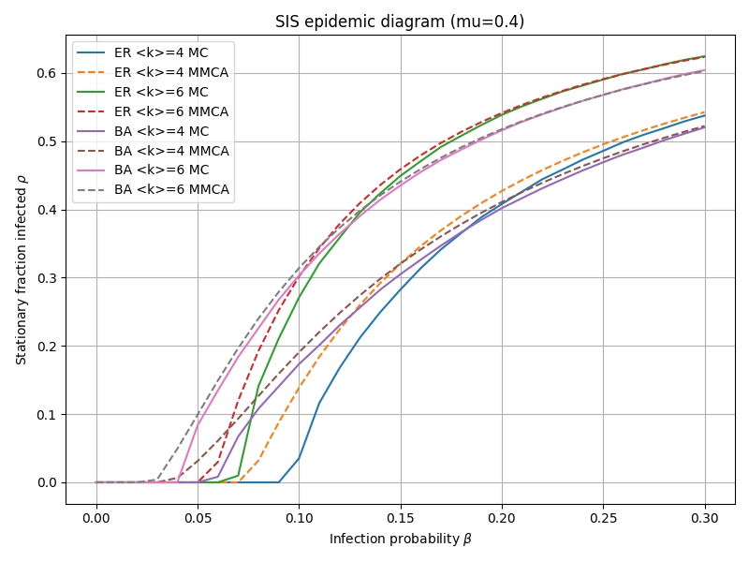Figure 2: Infected fraction versus infection probability at stationary state, given μ=0.4

More precisely, every node is marked as infected if an uniformly distributed random number between 0 and 1 is less than 0.2.

